Project Design Phase
Problem – Solution Fit Template

Date | 20-02-2026
Team ID | LTVIP2026TMIDS79278
Project Name | Electric Motor Temperature Prediction Using Meachine Learning
Maximum Marks | 2 Marks

Problem – Solution Fit Template:
Problem–Solution Fit Validation
Problem | Solution Fit
Unexpected overheating | Predicts temperature before failure occurs
High maintenance cost | Reduces hardware sensor dependency
Downtime losses | Enables predictive maintenance
Lack of monitoring | Provides real-time web-based monitoring
Reactive repair strategy | Enables proactive decision-making
The solution directly addresses the core pain points of industrial operators and provides measurable value.
Template:
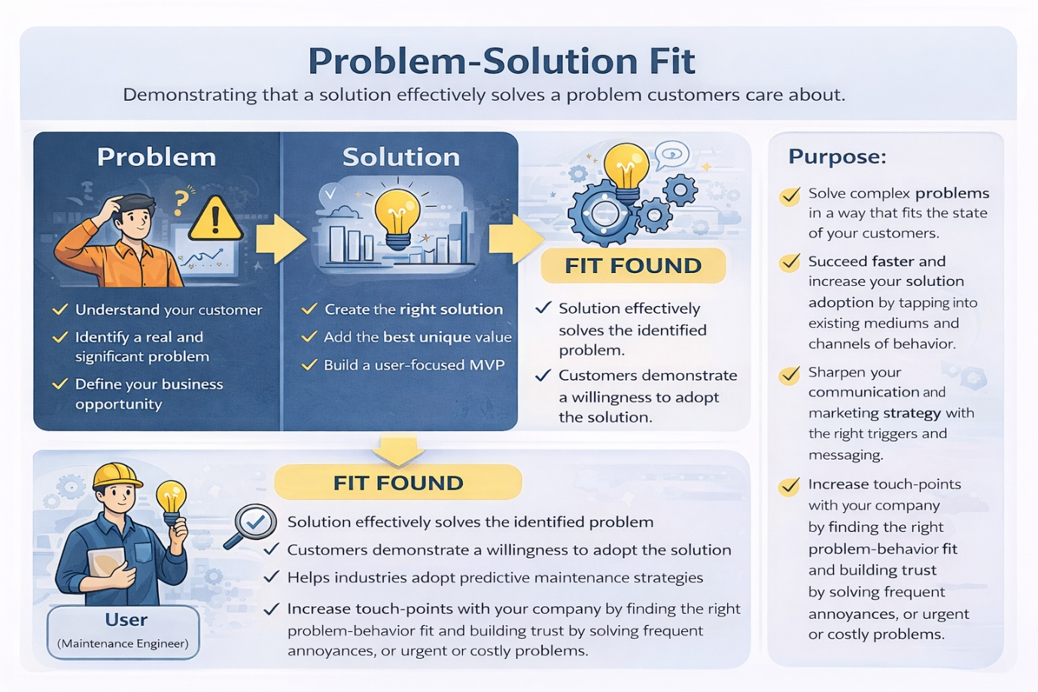

References:
- https://www.ideahackers.network/problem-solution-fit-canvas/
- https://medium.com/@epicantus/problem-solution-fit-canvas-aa3dd59cb4fe

